freETarget
Application Note: Advanced Operation

SUMMARY
FreeETarget was originally developed as a simple one user electronic target. Over the years the software and hardware have expanded to support a variety of different use cases. This document supplements the Service Manual to provide additional operating modes.
- Alternate power supplies
- Alternate communications modes
Each of these topics is provided in a separate chapter.
REQUIRED
- ESP32 Version 5.0 and higher
- ESP32 Firmware Version 6.3.0 or higher
- freETarget PC software

ALTERNATE POWER SUPPLIES
The FreeETarget was intended to be powered using the USB cable between the PC and the target. This provides enough current to power the board and locate pellet shots. It does not provide enough voltage or current to drive the LEDs or witness paper drive. To do this, an additional 12Volt supply is required.
Starting with Version 6.0, the target board includes a voltage regulator so that the board can be driven entirely from the 12Volt input.
Alternate power supplies are listed in Table 1:
Table 1: Alternate Power Supplies
Description | Amazon ASIN | Notes
12Volt, 2A wall supply | B091XSVV1Y | Use the wire adapter to connect between the power supply and the screw terminals on the ESP32 board (12V +/-)
Power tool battery adapter | B0DYK5D1QV | Use 24GA wire between the power tool adapter and the ESP32 screw terminals
ALTERNATE COMMUNICATIONS METHODS
The default operation of the target is a single target on a ten-meter range. This is satisfied using a fifteen-meter USB cable, or a battery and WiFi. When expanded to a large range with three or more lanes or longer distances, the WiFi can become problematic. To help in these cases, the target can be configured with alternative cabling or networks.
Connection | Advantage | Disadvantage | Works With
 |  |  | USB | RS485 | Eth | WiFI
USB Cable | Simple  Allows for target software updates | Requires special cable | X | X | X | 4
RS485 | Inexpensive Wiring | Requires that the target be powered by 12Volt Supply | X | X |  | 4
Ethernet | Reliable communications  Multiple Targets on one network | Requires cabling and a router to implement | X |  | X | 4
WiFi | Multiple targets on one network | Requires expertise in network management | X | X | X | 4
Any one target can use these communications methods either singly or together.

USB Connection
A single USB connection between the PC and the target is the simplest means of using the target. The USB provides communication and power to the target.
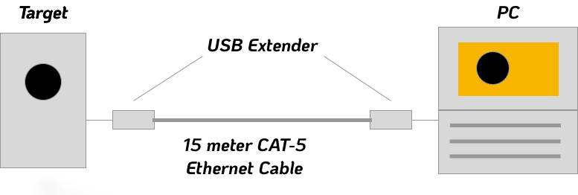
Figure 3: USB Extender
The Amazon.com order numbers are provided in Table 3.
Table 3: Amazon Part Numbers of USB Installation
Item | Description | AMAZON.COM ASIN
1 | USB Extender | B06WGVX3NQ
2 | CAT 5 Cable | B0BJNZ71K3
The single USB connection is recommended for each target lane since it provides an easy interface to each target and in addition to showing the shot data can be used for configuration and reprogramming.

RS485 Connection
FreeETarget supports a low cost RS485 connection between the PC and the target. While similar to the USB connection, RS485 does require that power be supplied through a USB connection or the external 12V supply.
Starting with board version 6.2 and higher, the RS-485 circuit is built onto the target circuit. For versions 5.0 to 6.1 you will need to add an additional adapter

Version 6.2 and Higher

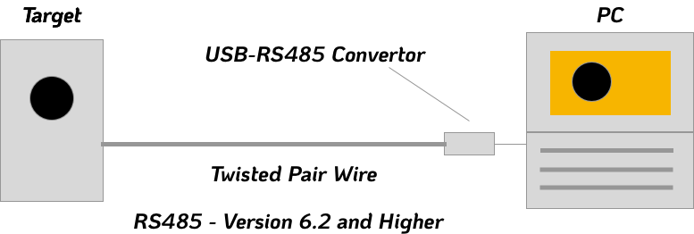

Starting with Version 6.2, the RS485 interface is installed directly onto the board. Simply attach the twisted pair wires to the A and B screw terminals and set the configuration into the software and reboot the board.
{“AUX_MODE”:8}
Table 4: Amazon Part Numbers of USB Installation
Item | Description | AMAZON.COM ASIN
1 | USB-RS485 Convertor | B07QN6JVG1
2 | Twisted Pair Wire | B0CQMSWVYY

Version 5.0 to 6.1

Prior to 6.2, FreeETarget boards do not have RS485 natively installed, but can be achieved by adding an ES485 convertor to the board and attaching it by a cable harness

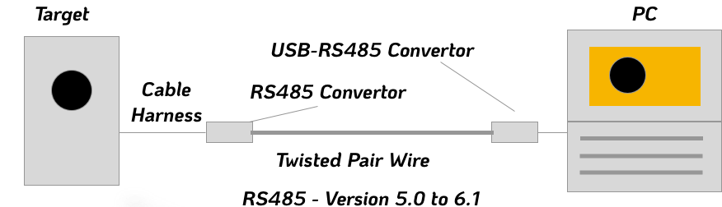
Figure 3: USB Extender
The Amazon.com order numbers are provided in Table 3.
Table 3: Amazon Part Numbers of USB Installation
Item | Description | AMAZON.COM ASIN
1 | USB Extender | B06WGVX3NQ
2 | CAT 5 Cable | B0BJNZ71K3

The cable harness between the ESP32 board and the RS485 adapter is given in Figure
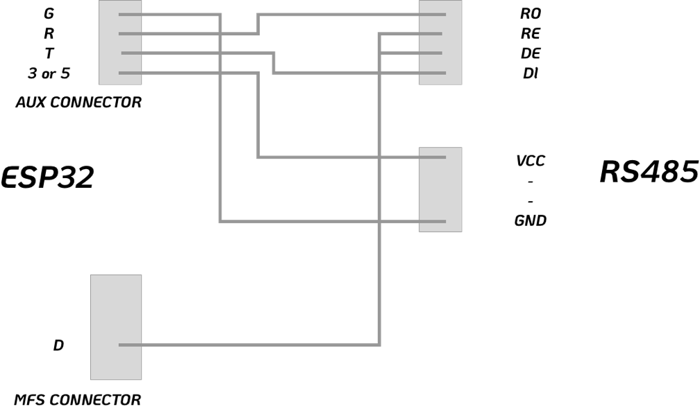

The RS485 driver is enabled by
{“AUX_MODE”:8, “MFS_HOLD_D”:30}

Wired LAN (Ethernet) Connection
A wired Ethernet connection is a reliable way of connecting all of the targets in a range. This method provides the advantage of multiple connections without collisions.
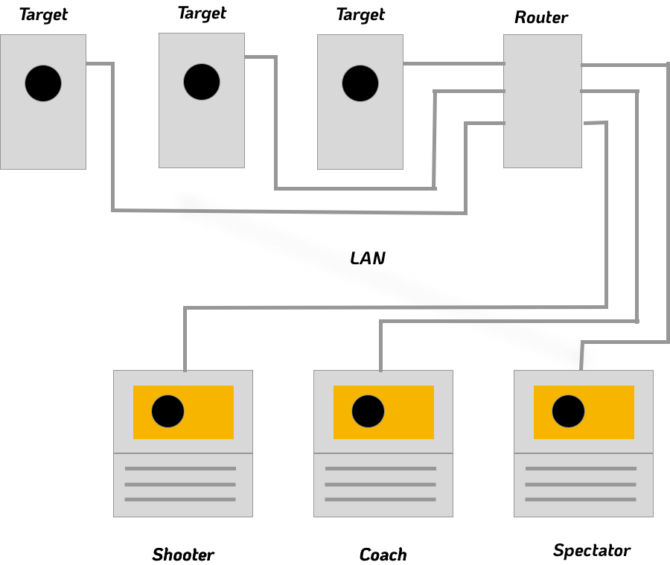

The FreeETarget connects to the LAN using an Ethernet adapter as shown in Figure
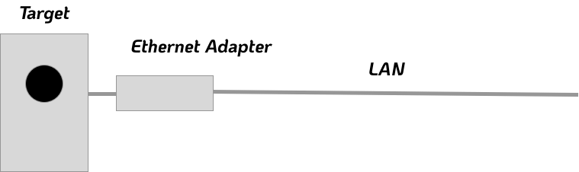

Each target requires the items shown in Table

Item | Description | Part Number
1 | Ethernet Serial Convertor | USR-TCT232-T2
2 | CAT 5 Cable | Amazon B0BJNZ71K3

The connection between the ESP32 board and the convertor depends on the version of ESP board that is used.

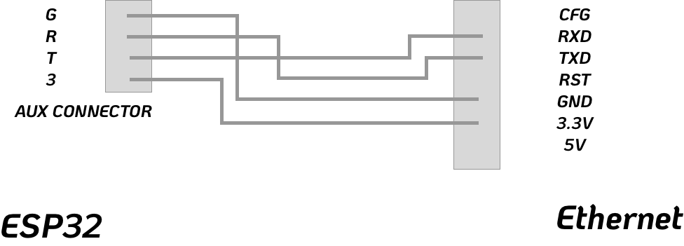Version 6.2 and higher

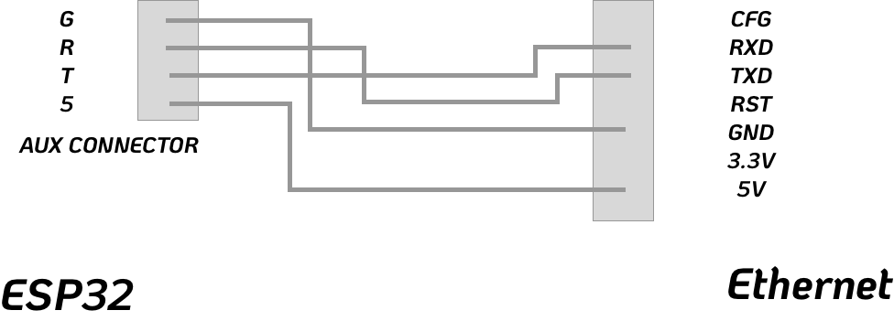
Version 5.0 to 6.1
Note that Version 5.0 to 6.1 supply 5 Volts, while 6.2 and higher supply 3.3
Once attached, the FreeETarget board is configured with
{“AUX_MODE”:1}
Programming the USR-TCP232-T2
The USR-TCP-232-T2 needs to be set up with the following
- The IP address of the convertor to be used on the host network
- Set into server mode
- Setup with the correct communication port
- Setup the communications rate
The first time through, the modules must be programmed in a specific sequence.
- Power the module from a FreeETarget board
- Directly connect the convertor to the PC using a direct wired connection
- Open the LAN setup from your PC setup tab
- Set your PC for a static IP with
  - IP address 192.168.0.1
  - Subnet Mask 255.255.255.0
  - DNS lookup 192.168.0.7
- Open a web browser and connect to 192.168.0.7
- Password admin
- ID: admin
- Set the LAN converter to
  - an address on your desired network, something like 192.168.1.100
  - Server mode
  - Port 1090
- Save and exit the configuration
IMPORTANT
- The converter is very unforgiving if you forget the IP address you set it to.
- Mark the IP address onto the board
- DO NOT change the username or password. If you forget the password, there is no way to recover it
The manuals for the convertor can be found at
https://www.pusr.com/download/M0/USR-TCP232-T2-User-Manual-V1.1.pdf&ved=2ahUKEwj23JqOicuTAxXplWoFHVe8G9MQFnoECBsQAQ&usg=AOvVaw3Va5z5EbAdktlITQ1JQrvF
Configuration Software
https://www.pusr.com/support/faq/usr-tcp232-t2-basic-function-test.html

WiFi Operation
Multiple FreeETargets can be setup on a host network to provide interoperability across multiple targets and multiple PCs. This is illustrated in Figure.
When setup this way, any pc can be attached to any target so that a coach can jump between shooters to watch their progress.
In order to do this, the network has to be setup for the application.

SETUP THE RANGE
The range is setup as shown in Figure 1. The targets are installed as usual and located nearby is the WiFi router. The router should be no more than forty (30) meters from the targets. The Shooter’s PC should be located such that they get a strong signal from the router.
WiFi routers come with the ability to directly connect the PC to the router using an Ethernet cable. Leave this in place since it allows remote diagnostics via TeamViewer and the service PC.
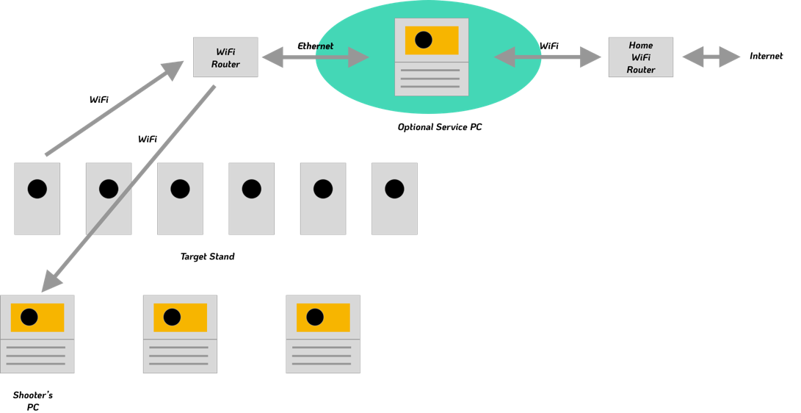
Figure 1: Preferred Range Setup
Router Setup
The router should be setup for the convenience of the shooter and their PC. The following settings are suggested.
Setting | Value | Description
SSID | TargetRange | Easy to recognize
Password | None (open wifi) | No secure data, easy to access for members
IP Address | 192.168.109.1 | Unique IP address that will not likely conflict with other networks

Target Setup
The target should be setup with the following values
Setting | Description
{“WIFI_SSID”:”TargetRange”} | Set to the same SSID as the router
{“WIFI_PWD”:””} | No password used.  Use {“WIFI_PWD”:”mypassword”} if a password is used in the router.
{“NAME_ID”:x} | Select a unique (different) name ID for each target  See Appendix
 | Optional
{“WIFI_IP”:”IP address”} | Set in a static IP, ex {“WIFI_IP”:”192.168.109.111”}

ASSIGN A TARGET NAME
Each target can be assigned a name so that it is easily identified later.
In the Generic Command field, enter the command
{“NAME_ID”:x} where X is the name ID. The list of
0 – FET-TARGET. (Default)
1 – FET-1  2 – FET-2  3 – FET-3  4 – FET-4  5 – FET-5  6 – FET-6  7 – FET-7  8 – FET-8  9 – FET-9  10 – FET-10 | 11 – DOC  12 – DOPEY  13 – HAPPEY  14 – GRUPMY  15- BASHFUL  16 – SNEEZY  17 - SLEEPY | 18 – RUDOLF  19 – DONNER  20 – BLITZEN  21 – DASHER  22 – PRANCER  23 – VIXEN  24 – COMET  25 – CUPID  26 - DUNDER | 27 – ODIN  28 – WODEN  29 – THOR  30 - BALDAR
Using a NAME_ID of 99 allows the operator to assign a new name to the target.
{“NAME_ID”:99, “NAME_TEXT”:”MyNewTarget”} -> FET-myName
{“NAME_ID”:10, “NAME_TEXT”:”MyNewTarget”} -> myName
{“NAME_ID”:101} ->FET-SerialNumber

ACCESSING THE TARGET
Once the targets and router have been setup, the target can be accessed much like any other network device you have.
Using the PC Client
In the client configuration, set in the IP address in the TCP configuration as shown in Figure 3
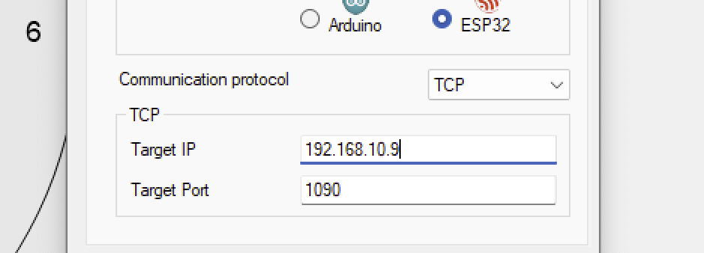
Figure 3: Setting the Target IP Address
When the target connects, it will connect to the IP address and begin the session.
The target will accept up to four simultaneous connections:
- Shooter
- Coach
- Parent
- Observer

Using a Web Browser
The target can be accessed as a web page using a web browser such as Safari or Chrome.
By IP address for example: 192.168.109.23
By target name, for example FET-TARGET.local

SECURITY
The design of FreeETarget assumed a fair amout of trust between the shooters and the shooting range. If this is not the case, then the following steps can be added
- Assign a WiFi password to the target range
- Lock out the target settings by assigning a lock code {“LOCK”:number}. This will prevent anyone from changing the settings unless an unlock code is provided {“UNLOCK”:number}

CAUTIONS
- When using the browser, only one connection will be accepted.
- The target has a WiFi range of fifty-meters in a clear line of sight with no obstructions
- The range manager should assign a WiFi password if they are concerned about security

